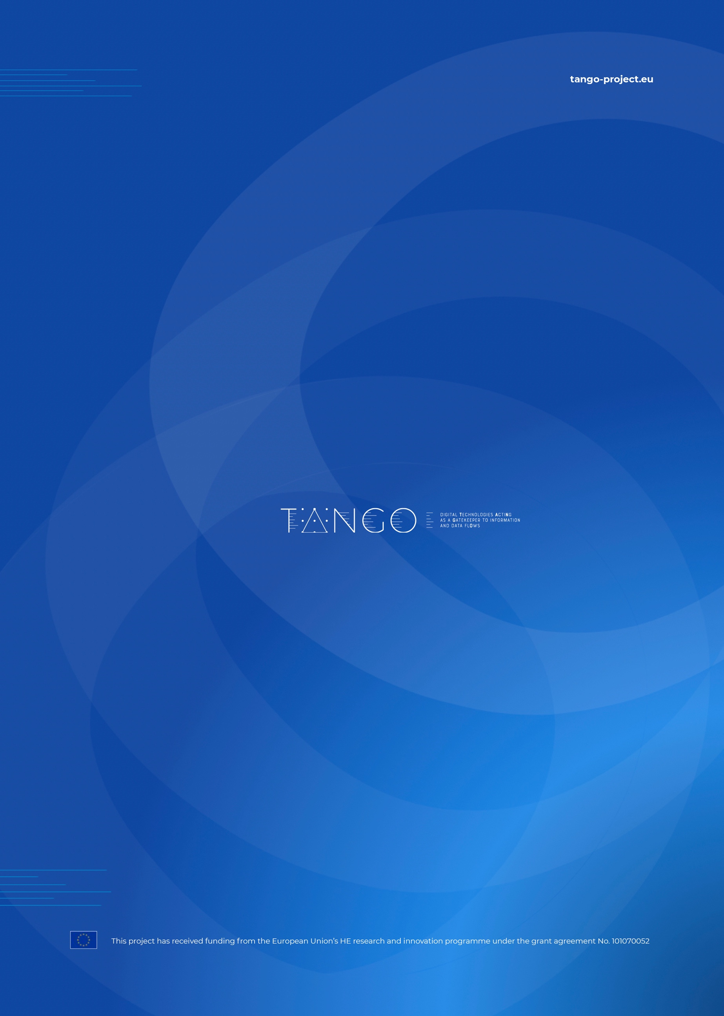

**NOTE TO EDITORS**

Please remove this section when starting the deliverable.

The template contains several guidelines in purple font to provide the deliverable editors with hints about the different sections.

The template also contains examples about format, fonts, and colours.

Please remove ALL guidelines in this document before submitting the deliverable to the European Commission.

# Document Information

In addition to the information contained on the cover page, this section provides overall information about contributors and major changes to the document along its iterative production.

Do not forget to enter all contributors from all organizations participating in this deliverable. This can be used as an evidence for effort claiming.

|  |  |
| --- | --- |
| List of Contributors | |
| Name | Partner |
| Name Surname | Beneficiary short name |
|  |  |
|  |  |

|  |  |  |  |
| --- | --- | --- | --- |
| Document History | | | |
| Version | Date | Change editors | Changes |
| 0.1 | dd/mm/yyyy | Name (Organisation short name) | Brief explanation of changes applied (in case changes due to the internal review, please indicate here). |
| 0.2 |  |  |  |
| 1.0 |  |  | FINAL VERSION TO BE SUBMITTED |

|  |  |  |
| --- | --- | --- |
| Quality Control | | |
| Role | Who (Partner short name) | Approval Date |
| Deliverable leader | Name (Organisation short name) | dd/mm/yyyy |
| Quality manager |  |  |
| Project Coordinator |  |  |

Table of Contents

Document Information 3

Table of Contents 4

List of Tables 5

List of Figures 6

List of Acronyms 7

Executive Summary 8

1 Introduction 9

1.1 Purpose of the document 9

1.2 Relation to other project work 9

1.3 Structure of the document 9

1.4 Glossary adopted in this document 9

2 Conclusions 10

3 Title” Styles 11

3.1 “Title 2” 11

3.2 “Title 2” 11

3.2.1 “Title 3” 11

3.2.2 “Title 3” 11

4 Managing the formats of the template 12

4.1 How to use the bullets: 12

4.2 How to manage Tables 12

4.3 How to manage Figures 14

4.4 How to insert a Landscape page 15

4.5 How to create References 16

4.5.1 Method 1: Including cross-reference: 16

4.5.2 Method 2 – Insert Citation 17

5 “References 18

6 Bibliography 19

Annexes 20

List of Tables

Table 1: title 10

List of Figures

Figure 1: title 10

List of Acronyms

Insert here all the acronyms appearing along the deliverable in alphabetical order.

|  |  |
| --- | --- |
| Abbreviation / acronym | Description |
| EC | European Commission |
| Dx.y | Deliverable number y belonging to WP x |
| WP | Work Package |
|  |  |
|  |  |
|  |  |
|  |  |
|  |  |
|  |  |
|  |  |
|  |  |
|  |  |

Executive Summary

The following text is a generic guideline for the authors to produce the Executive Summary section. This text marked in purple should be deleted before submitting for internal review.

Please follow these guidelines:

* **Length:** please limit it to 1 page (2 pages in exceptional cases).
* **ALL deliverables** must have conclusions
* **Goal:** The Executive summary is not an “introduction” to the deliverable. The main goal of this section is to provide readers with a whole picture of the document (i.e. the Abstract section from the papers), so that they can understand the content of the deliverable at once without further reading.
* **Self-contained:** If there is any input coming from other deliverables, it must be mentioned here.
* **Motivation for the reader** (Recommended: 1 –10 lines):
* What is the reason for being for this deliverable? Which challenges it addresses?
* What will the reader learn from it?
* Main results and findings (Recommended: 5 to 50 lines):
* What are the main results achieved?
* How does it contribute in the [INSERT PROJECT SHORT NAME HERE]-context?
* Short conclusions (Recommended: 1 to 10 lines):
* Key takeaway messages
* Style:
* Please use a formal and practical writing style without jargon.
* Do not use ”We” when writing the Executive Summary.

Add your text here.

# Introduction

## Purpose of the document

The objective of this subsection is to explain the objective of the document in alignment with the DoA and the project roadmap.

Add your text here.

## Relation to other project work

The objective of this subsection is to describe how the present document relates to the DoA, the project roadmap, as well as to other existing deliverables. This section could be end of the document (before references) if you see fit.

Add your text here.

## Structure of the document

The objective of this subsection is to present readers/reviewers the structure of the document, while presenting an insight before the core.

This document is structured in X major sections.

**Section 2** presents…

**Section 3** presents…

# Title” Styles

Enter your text here.

## “Title 2”

Enter your text here.

## “Title 2”

Enter your text here.

### “Title 3”

Enter your text here.

### “Title 3”

Enter your text here.

#### “Title 4”

Enter your text here.

#### “Title 4”

Enter your text here.

##### “Title 5”

Enter your text here.

# Managing the formats of the template

This section includes format examples to follow - please delete these examples when starting the deliverable.

**Template Colour palette:**



This is the colour used for this template. The colour should change when adapting the template to each project, in order to respect each graphical identity (logo).

**This is an example of text:** Lorem ipsum dolor sit amet, consectetuer adipiscing elit, sed diam nonummy nibh euismod tincidunt ut laoreet dolore magna aliquam erat volutpat. Ut wisi enim ad minim veniam, quis nostrud exerci tation ullamcorper suscipit lobortis nisl ut aliquip ex ea commodo consequat.

## How to use the bullets:

* Go to Multilevel List: Home/Paragraph/Multilevel List
* Select ARI LISTA style from the List Style options.
* Level 1
  + Level 2
    - Level 3
      * Level 4
        + Level 5

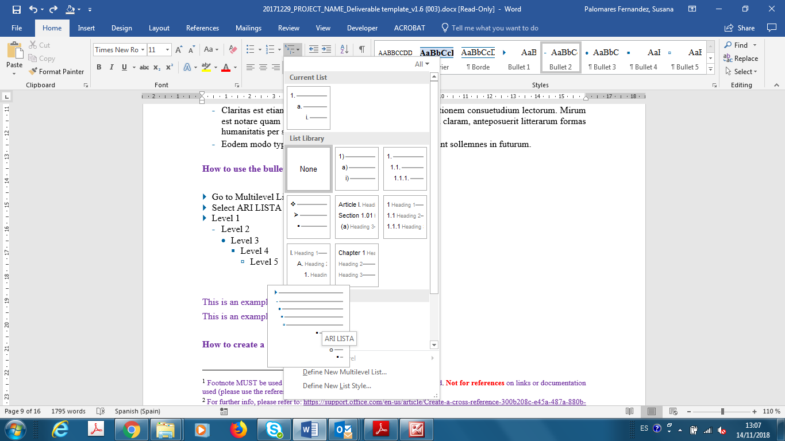

## How to manage Tables

**This is an example for a table:**

* Captions always on top.
* Check that the table header repeats at the top of each page, if the page breaks across pages.
* Update the list of tables at the beginning of the document. Check that the numbering sequence is correct.

Table 1: title

|  |  |  |
| --- | --- | --- |
| Header 1 | Header 2 | Header 3 |
|  |  |  |
|  |  |  |
|  |  |  |
|  |  |  |

**How to change the color of the default table for the template:**

1. Insert any table
2. Select the default table and with the righ botton, modify

1. Modify the color of the border and the header row

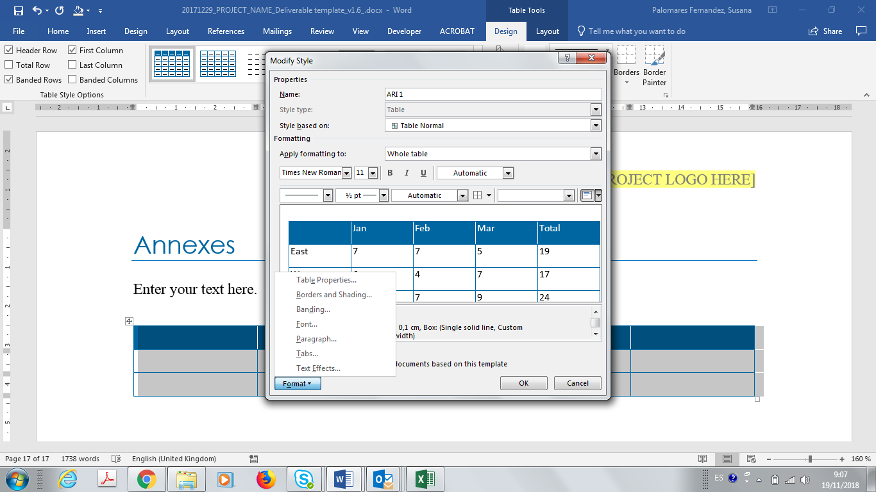

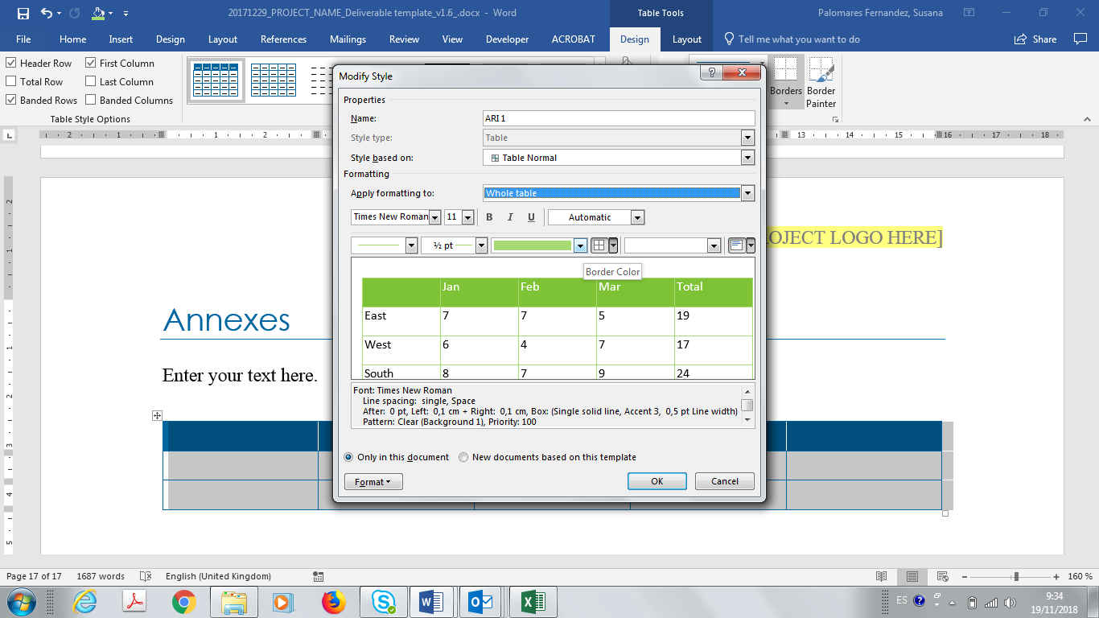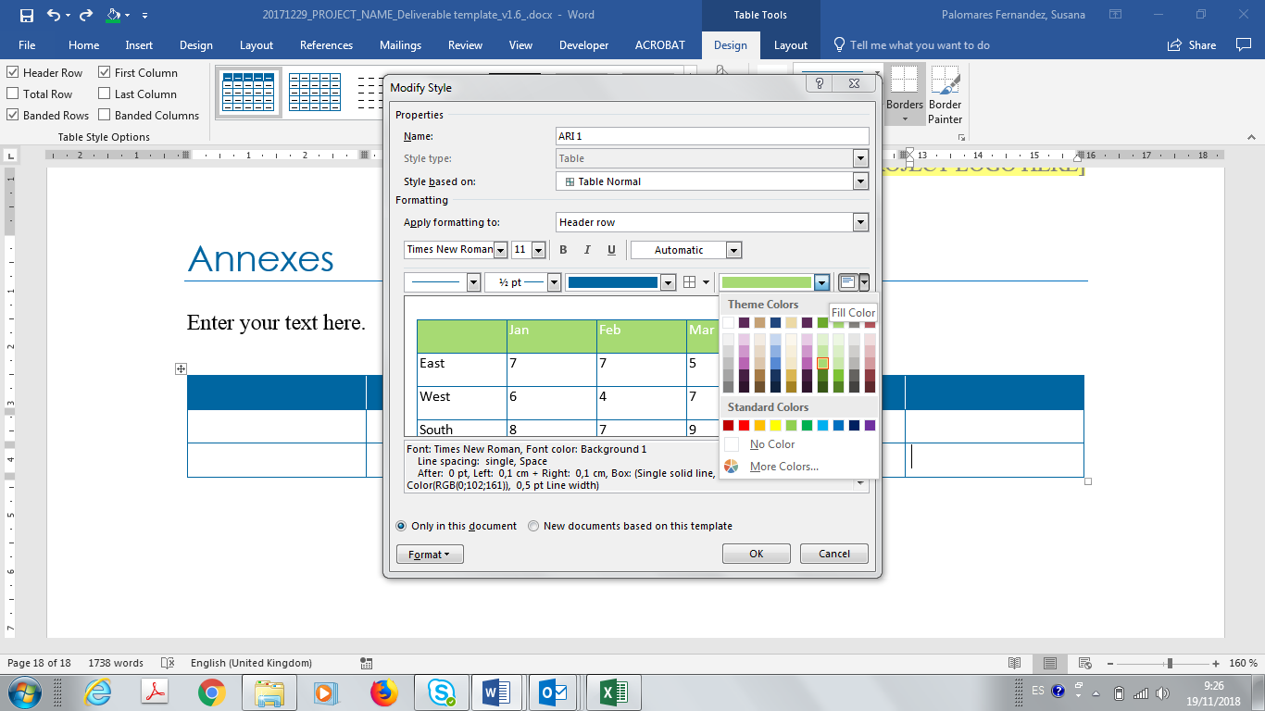

## How to manage Figures

**This is an example for a Figure:**

* Captions always at the bottom.
* Update the list of figures at the beginning of the document. Check that the numbering sequence is correct.
* Always use the automatic numbering format for figures as provided in the caption of the figure below



Figure 1: title

Figure source: [1] – [Please include cross-reference here of the external image source in case of copyrighted images]

## How to insert a Landscape page

1. Inser a new section twice: Layout/Breaks/Next Page (the page must be a section itself. An “extra” blank page will be created)
2. Click on the Header and the Footer of the page you want to be landscape and unselect LINK TO THE PREVIOUS
3. Click on the Header and the Footer of the NEXT page you want to be landscape and unselect LINK TO THE PREVIOUS

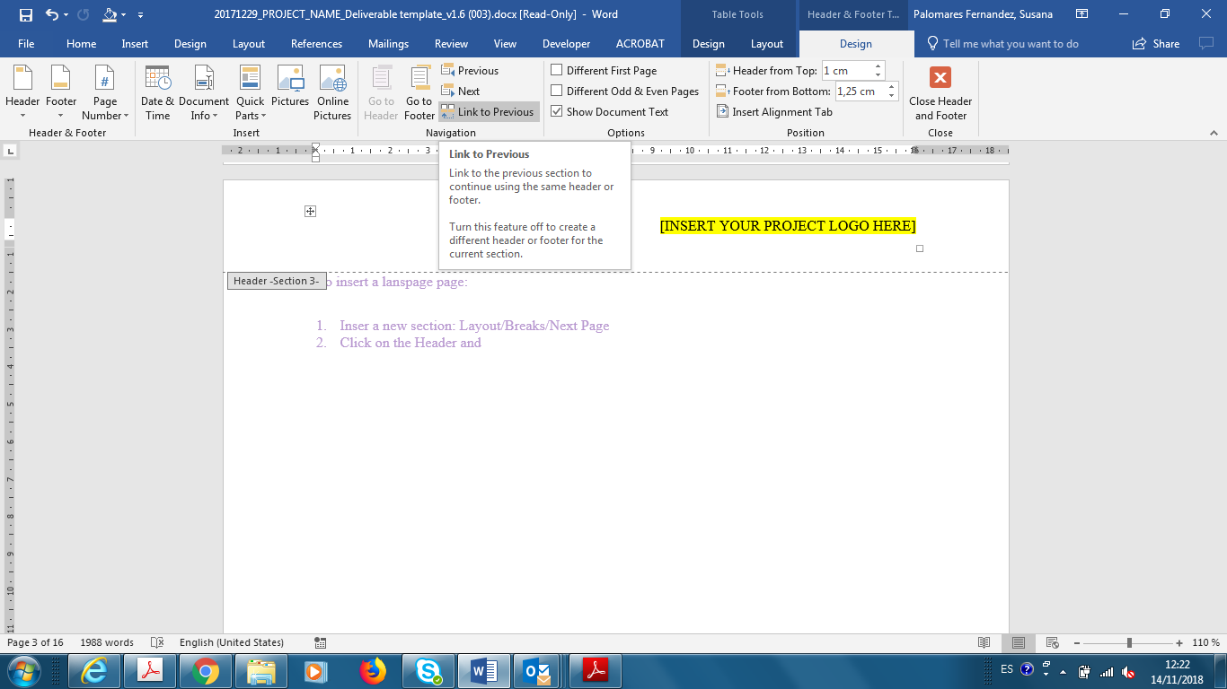

1. Delete the “extra” blank page
2. Change the layout to landscape: Layout/Orientation/Landscape

## How to create References

Before your release the template to the Consortuim, you have to choose the reference method to be used.

### Method 1: Including cross-reference**[1]**:

**IMPORTANT:** If you choose this method, please delete the Bibliography section, leaving only the references section available for the consortium.

1. Go to the Reference section and add your reference following the provided model and style.

2. Place your cursor in the main text where the cross-reference should be inserted.

3. Click **Insert | Cross-reference.** *A***Cross-reference***dialog box will appear.*

4. Click the **Reference type:** drop down and select the type of object you want to provide a cross-reference to

5. Click the **Insert reference to:** drop down and select the information to be displayed in the cross-reference field

6. Available headings, captions or footnotes will appear. Select the item you wish to reference

7. Click **Insert**

This is an example of cross-reference: [1]

This is an example of footnote: Text[2]

This is an example of figure reference: Figure source: [1] – [Please include cross-reference here of the external image source in case of copyrighted images]

### Method 2 – Insert Citation

**IMPORTANT:** If you choose this method, please delete the References section, leaving only the Bibliography section available for the consortium.

Use of MS-Word Bibliography function to generate bibliography section for citation. With this method, the editors will have to introduce the data of the sources used in the document, and MS-WORD will generate a full Bibliography section automatically.

Check the end of the document (Bibliography section), the current sample of bibliography section, using the following examples of citation:

This is an example of bibliography citation for a Book (Author surname, year of publication (i.e. 2003))

This is an examplele of bibliography citation for an article: (Title (i.e. The power of peers), year of publication (i.e. 2002))

This is an example of bibliography citation for articles on websites: (Author Surname, Year of publication or most recent update (i.e. 1999))

This is an example of bibliography citation for Deliverable: (Lead author (surname, Year (i.e. 2015))

This is an example of bibliography citation for Websites: ()

**How to create references with this method:**

1. Put your cursor at the end of the text you want to cite.
2. Go to References >Style and choose the citation style ISO 690.
3. Select Insert Citation.
4. Choose Add New Source and fill out the information about your source.

Once you've added a source to your list, you can cite it again:

1. Put your cursor at the end of the text you want to cite.
2. Go to References > Insert Citation and choose the source you are citing.
3. To add details, like page numbers if you're citing a book, select Citation Options, and then Edit Citation.

For more info on how to create and maintain references with this method, refer to:

<https://support.office.com/en-us/article/create-a-bibliography-citations-and-references-17686589-4824-4940-9c69-342c289fa2a5>

# Conclusions

The following text is a guide line to provide conclusions – please delete this section before sending for internal review.

Please follow these guidelines, please:

* **ALL deliverables** must have conclusions (only in exceptional cases it can be avoided – management reports).
* Include the main conclusions reached in this document (challenges addressed and not addressed).
* If applicable include the main results.
* Include information concerning the tasks/deliverables that are requiring input from this document (i.e. the results of this document will be used as input in the following deliverables…).
* Include the following steps to take in the project to follow up the work presented in this deliverable and in alignment with the project roadmap.

Add your text here.

# References

This section contains the references that underpin your claims along the deliverable.

Here you can find the format to follow for references and some examples.

References have to be used by means of cross-reference. See example added in section 3.5. Remove these lines in your deliverable.

1. **Books:** Author Surname, First name initials, (Year of Publication), Book Title (Edition), Publisher, City of Publication. (Example: Levenstein, H. A. (2003), *Revolution at the table: The transformation of the American diet*, University of California Press, Berkeley.)
2. **Articles in Journals:** Author Surname, First name initials, (Year of Publication), Article Title, Periodical, Volume and Issue, Pages. (Example: Hoxby, C. M. (2002), The power of peers, *Education Next*, *2*(2), 57-63.)
3. **Articles on Websites:** Author Surname, First name initials, (Year of Publication or most recent Update), Website/Article Title, Website URL, [Date of accessyyyy-mm-dd]. (Example: Cain, A., & Burris, M. (1999). *Investigation of the use of mobile phones while driving*, <http://www.cutr.eng.usf.edu/its/mobile_phone_text.htm>, retrieved 2017-11-06)
4. **Deliverable:** [PROJECT NAME] [*DELIVERABLE TITLE*] [LEAD AUTHOR (surname,name)] [YEAR]. (Example: WITDOM. *D2.2 - Functional analysis and use cases identification*. Alberti Francesco. 2015)
5. **Websites:** [WEB NAME], [*PAGE TITLE*],[URL], [retrieved date yyyy-mm.dd] (Example: WITDOM. *Deliverables*. <http://www.witdom.eu/deliverables> , retrieved 2017-11-06)

# Bibliography

**Author Surname, First name initials (i.e. Cain, A., & Burris). Year of publication or most recent update (i.e. 1999).** Name of Web Page (i.e. Investigation of the use of mobile phones while driving). *Name of Web Site (i.e. Research WebSite).* [Online] Year of publication or most recent update (i.e. 1999). [Cited: Month of access (i.e. 11) Day of access (i.e. 06), Year of access (i.e. 2017).] Website URL (i.e. http://www.cutr.eng.usf.edu/its/mobile_phone_text.htm).

**Author surname, first name initials (i.e. Levenstein, H. A.). year of publication (i.e. 2003).** *Title (i.e. Revolution at the table: The transformation of the American diet).* City (i.e. Berkeley) : Publisher (i.e. University of California Press), year of publication (i.e. 2003).

**d. d.** *d.* d.

**Lead author (surname, name) (i.e. Alberti Francesco). Year (i.e. 2015).** *Project name, deliverable number and title (i.e. WITDOM. D2.2 - Functional analysis and use cases identification).* Year (i.e. 2015).

*Title (i.e. The power of peers).* **Author (i.e. Hoxby, C. M.). year of publication (i.e. 2002).** Issue and pages (i.e. 2 - 57-63), s.l. : Publisher (i.e. Publisher), year of publication (i.e. 2002), Vol. Volume (i.e. 2).

Web Page Name (i.e. Deliverables). *Web Site Title (i.e. WITDOM).* [Online] [Cited: month accessed (i.e. 11) day acceessed (i.e. 06), year accessed (i.e. 2017).] web url (i.e. http://www.witdom.eu/deliverables).

The examples above refer to: (Please delete this text before releasing the document to the EC)

1 – Book

2 – Article

3 – Article on website

4 – Deliverable

5 - Website

# Annexes

Enter your text here.

1. For further info, please refer to: <https://support.office.com/en-us/article/Create-a-cross-reference-300b208c-e45a-487a-880b-a02767d9774b>
2. Footnote MUST be used only for additional clarification on the text provided. **Not for references** onlinks or documentation used (please use the references instead).